Table of Contents
1. Problem Definition & Data Collection: 3
1.1. Detailed Google Maps Evidence Records 4
2. Problem Analysis: 9
2.1. Assumptions: 9
2.2. Path Cost Functions: 10
2.3. Value Normalization: 11
3. Code Implementation 12
3.1. State Representation 12
3.2. Actions & Transition Model 13
3.3. Heuristic Function 14
3.4. Cost Function 16
3.5. Evaluation Function 17
3.6. Code Implementation Considerations 17
3.7. Modification for Different Configurations 17
4. Result Visualization 18
5. Evaluation and Discussions 23
Appendix A: Individual Reflection 25

Problem Definition & Data Collection:

Our aim in this report is to implement the informed search, A* search algorithm into our route-finding problem by using Python. We have a total of 7 nodes, indicating the 6 members within our team with a starting point of Sunway University, shown as below:
Node | Member
A | Sunway University (Start)
B | Tan Jia Ming
C | Pang Wei Sheng
D | Tan Li Yang
E | Yeoh Choon Hern
F | Thow Zhi Cheng
G | Dinesswar A/L Sathasivam (Goal)
Table 1: Team Member Residential Address Table
Considering each node must be visited once, this route planning problem is modelled as an Asymmetric Traveling Salesperson Problem (ASTP) to fulfill and reflect real world route planning scenarios.
All route data was collected from Google Maps using a fixed 3:00 PM departure time. There will be 2 routes data:
- By car
- By motorbike
Unless otherwise stated, driving is used for route data, Short local movements of 1 km or below may be treated as walking edges with 0 L fuel use and 0 g carbon emissions. The fuel usage and carbon emission for car and motorbike are respectively:
 | Fuel Usage Formula | Carbon Emission Formula
Car | 7.2L/100km | 150g/km
Motorbike | 2.5L/100km | 113g/km
Table 2: Fuel Usage & Carbon Emission Formula for Car & Bike

Detailed Google Maps Evidence Records
    - Car:
From | To | Distance (km) | ETA (min) | Remark | Evidence URL
A | B | 0.16 | 2-4  (avg 3) | Walking
A | C | 0.55 | 6-10  (avg 8) | Walking
A | D | 2.9 | 6-12  (avg 9) | Fuel: 0.21 L  Carbon: 435 g
A | E | 6.5 | 12-35  (avg 23.5) | Fuel: 0.47 L  Carbon: 975 g
A | F | 14.2 | 16-35  (avg 25.5) | Fuel: 1.02 L  Carbon: 2130 g
A | G | 68.3 | 55-90  (avg 72.5) | Fuel: 4.92 L  Carbon: 10245 g
B | A | 0.16 | 2-4  (avg 3) | Walking
B | C | 1.0 | 6-12  (avg 9) | Walking
B | D | 3.2 | 7-14  avg (10.5) | Fuel: 0.23L  Carbon: 480g
B | E | 7.1 | 10-30  (avg 20) | Fuel: 0.51 L  Carbon: 1065 g
B | F | 14.1 | 16-28  (avg 22) | Fuel: 1.02L  Carbon: 2115g
B | G | 71.8 | 70-90  (avg 80) | Fuel: 5.17 L  Carbon: 10770 g
C | A | 0.55 | 7-9  (avg 8) | Walking
C | B | 1.0 | 6-12  (avg 9) | Walking
C | D | 2.7 | 6-9  (avg 7.5) | Fuel: 0.19 L  Carbon: 405 g
C | E | 7.5 | 14-35  (avg 24.5) | Fuel: 0.54 L  Carbon: 1125 g
C | F | 15.3 | 18-35  (avg 26.5) | Fuel: 1.10 L  Carbon: 2295 g
C | G | 68.0 | 55-90  (avg 77.5) | Fuel: 4.90 L  Carbon: 10200 g
D | A | 4.6 | 9-18  (avg 13.5) | Fuel: 0.32L  Carbon: 690g
D | B | 4.2 | 9-16  (avg 12.5) | Fuel: 0.30 L  Carbon: 630 g
D | C | 3.9 | 8-14  (avg 11) | Fuel: 0.28 L  Carbon: 585 g
D | E | 8.7 | 14-28  (avg 21) | Fuel: 0.63 L  Carbon: 1305 g
D | F | 15.0 | 16-35  (avg 25.5) | Fuel: 1.08 L  Carbon: 2250 g
D | G | 65.9 | 50-85  (avg 67.5) | Fuel: 4.74 L  Carbon: 9885 g
E | A | 7.8 | 14-35  (avg 24.5) | Fuel: 0.56  Carbon: 1170g
E | B | 7.3 | 12-30  (avg 21) | Fuel: 0.53L  Carbon: 1095g
E | C | 7.7 | 14-35  (avg 25) | Fuel: 0.55 L  Carbon: 1155 g
E | D | 6.4 | 10-26  (avg 18) | Fuel: 0.46L  Carbon: 960g
E | F | 19.9 | 20-35  (avg 27.5) | Fuel: 1.43L  Carbon: 2985g
E | G | 72.3 | 55-100  (avg 77.5) | Fuel: 5.21 L  Carbon: 10845 g
F | A | 13.4 | 16-28  (avg 22) | Fuel: 0.97L  Carbon: 2010g
F | B | 13.5 | 16-30  (avg 23) | Fuel: 0.97 L  Carbon: 2025 g
F | C | 13.1 | 16-26  (avg 21) | Fuel: 0.94 L  Carbon: 1965 g
F | D | 14.6 | 16-26  (avg 21) | Fuel: 1.05L  Carbon: 2190g
F | E | 18.5 | 24-45  (avg 34.5) | Fuel: 1.33 L  Carbon: 2775 g
F | G | 73.8 | 60-110  (avg 85) | Fuel: 5.31 L  Carbon: 11070 g
Table 3: Detailed Google Maps Route Evidence Record Table (Car)
    - Motorbike:
From | To | Distance (km) | ETA (min) | Remark
A | B | 0.16 | 2-4  (avg 3) | Walking
A | C | 0.55 | 6-10  (avg 8) | Walking
A | D | 2.9 | 6-12  (avg 9) | Fuel: 0.072 L  Carbon: 328 g
A | E | 6.5 | 15-20  (avg 17.5) | Fuel: 0.163 L  Carbon: 735 g
A | F | 14.2 | 16-22  (avg 19) | Fuel: 0.355 L  Carbon: 1605 g
A | G | 68.3 | 55-75  (avg 65) | Fuel: 1.708 L  Carbon: 7718 g
B | A | 0.16 | 2-4  (avg 3) | Walking
B | C | 1.0 | 6-12  (avg 9) | Walking
B | D | 3.2 | 9-13  avg (11) | Fuel: 0.08L  Carbon: 362g
B | E | 7.1 | 14-22  (avg 18) | Fuel: 0.177 L  Carbon: 802g
B | F | 14.1 | 13-23  (avg 18) | Fuel: 0.353L  Carbon: 1593g
B | G | 71.8 | 51-64  (avg 57.5) | Fuel: 1.795 L  Carbon: 8113g
C | A | 0.55 | 7-9  (avg 8) | Walking
C | B | 1.0 | 6-12  (avg 9) | Walking
C | D | 2.7 | 5-9  (avg 7) | Fuel: 0.068 L  Carbon: 305 g
C | E | 7.5 | 14-18  (avg 16) | Fuel: 0.188 L  Carbon: 848 g
C | F | 15.3 | 13-21  (avg 17.5) | Fuel: 0.383 L  Carbon: 1729 g
C | G | 68.0 | 50-72  (avg 61) | Fuel: 1.7 L  Carbon: 7684 g
D | A | 4.6 | 5-9  (avg 7) | Fuel: 0.115L  Carbon: 520g
D | B | 4.2 | 5-11  (avg 8) | Fuel: 0.105 L  Carbon:475 g
D | C | 3.9 | 3-5  (avg 4) | Fuel: 0.098 L  Carbon: 441 g
D | E | 8.7 | 10-16  (avg 13) | Fuel: 0.217 L  Carbon: 983 g
D | F | 15.0 | 13-21  (avg 17) | Fuel: 0.375 L  Carbon: 1695 g
D | G | 65.9 | 48-72  (avg 60) | Fuel: 1.648 L  Carbon: 7447 g
E | A | 7.8 | 15-23  (avg 19) | Fuel: 0.195L  Carbon: 881g
E | B | 7.3 | 14-24  (avg 19) | Fuel: 0.182L  Carbon: 825g
E | C | 7.7 | 13-21  (avg 17) | Fuel:0.193 L  Carbon: 870 g
E | D | 6.4 | 12-16  (avg 14) | Fuel: 0.16L  Carbon: 723g
E | F | 19.9 | 26-33  (avg 29) | Fuel: 0.497L  Carbon: 2249g
E | G | 72.3 | 49-80  (avg 69) | Fuel: 1.808 L  Carbon: 8170 g
F | A | 13.4 | 15-25  (avg 20) | Fuel: 0.335L  Carbon: 1526g
F | B | 13.5 | 14-29  (avg 22) | Fuel: 0.338L  Carbon: 2025 g
F | C | 13.1 | 15-23  (avg 19) | Fuel: 0.328 L  Carbon: 1480g
F | D | 14.6 | 15-25  (avg 20) | Fuel: 0.365L  Carbon: 1650g
F | E | 18.5 | 21-27  (avg 24) | Fuel: 0.463L  Carbon: 2091 g
F | G | 73.8 | 60-100  (avg 80) | Fuel:1.845L  Carbon: 8339.4 g
Table 4: Detailed Google Maps Route Evidence Record Table (Motorbike)
The distance matrix is asymmetric (dᵢⱼ ≠ dⱼᵢ), reflecting real-world road constraint such as one-way roads and highway configurations. For example, C à D = 2.7 km while D à C = 3.9 km. This reflects real-world road constraints such as one-way roads and highway configurations. Thus, the problem is modelled as ASTP and not TSP. Some walking route such as A↔B is symmetric as the same pedestrian route can be reused.

Problem Analysis:
Initial State | (A, {A})  [Starting at Sunway University (A), with only A inside the visited set]
Goal State | (G, {A, B, C, D, E, F, G})  [Arriving at Dinesswar’s home (G), with all nodes inside the visited set]
Algorithm | A* search
Cost Factor Functions: | - Carbon emission formula: 150g/km  - Fuel usage: 7.2L/100km
Actions | Move from current Location L1 to another Location L2
Transition Model | Result ((L1​, V), L2​) = (L2​, V ∪ {L2​})  [Location updates to L2, and L2 is appended to the visited tracking set]
Table 5: Problem Analysis Table
To model this routing scenario accurately as an ATSP, the state space tracks both the traveler’s current physical position and the unique set of visited locations. This prevents premature convergence at the goal sink node, which has no outgoing edges.

Assumptions:
- Each node must be passed through at least one in the route
- Current goal node is chosen due to its large distance from other team members
- Due to goal node is tremendously further than everyone else, it won’t have any outgoing edges
- The heuristic of A* search would be based on Minimum Spanning Tree (MST) lower bound
- Chose the optimal routes that were defined by google map, taking in:
  - Time of leaving: 3p.m.
  - Distance
  - Estimate Time Arrival (ETA)
  - Carbon emission formula: 150g/km | 113g/km
  - Fuel usage: 7.2L/100km | 2.5L/100km

Path Cost Functions:
Considering there are many other cost factors to account for in this route planning problem, which includes distance, estimated arrival time, fuel consumption and carbon emission. Thus, each factor is normalized with a weighted score unit as shown below:
WX = $\frac{Vx - Vmin}{Vmax - Vmin} ×$Weightage
- WX: Either WD, WE, WF, WC
- VX: The value of that factor on that node
- VMAX: The maximum value of that factor
- VMIN: The minimum value of that factor
- Weightage:
  - 0.5 (ETA)
  - 0.2 (Distance)
  - 0.2 (Fuel)
  - 0.1 (CO²)

ETA was assigned the highest weight (0.5) because minimizing travel time was considered the primary objective of the route-planning problem. Distance and fuel consumption were assigned moderate weights (0.2 each) because they directly influence travel efficiency and operational cost. Carbon emission was assigned a lower weight (0.1) because it is strongly correlated with fuel consumption and therefore indirectly accounted for through the fuel component. Then we can sum up all the cost factor to indicate the true path cost of that node:
Cost = WD + WE + WF + WC
- WD: Distance
- WE: Estimated arrival time (ETA)
- WF: Fuel Consumption
- WC: Carbon Emission

All normalized costs in the matrix above were computed using global min-max normalization across all four foundational metrics. Local walking edges of 1 km or below correctly map to near-zero costs because their fuel and carbon components evaluate to absolute zero, leaving only their minimal normalized distance and walking duration to influence the total edge weight.

Value Normalization:
From \ To | A | B | C | D | E | F | G
A | - | 0.0000 | 0.0315 | 0.0559 | 0.1687 | 0.2330 | 0.8867
B | 0.0000 | - | 0.0389 | 0.0670 | 0.1513 | 0.2112 | 0.9561
C | 0.0315 | 0.0389 | - | 0.0452 | 0.1815 | 0.2466 | 0.9152
D | 0.0944 | 0.0859 | 0.0748 | - | 0.1685 | 0.2385 | 0.8397
E | 0.1835 | 0.1590 | 0.1858 | 0.1344 | - | 0.2838 | 0.9444
F | 0.2065 | 0.2130 | 0.1981 | 0.2083 | 0.3170 | - | 1.0000
G | - | - | - | - | - | - | -
Table 6: Normalization Value Table (Car)
From \ To | A | B | C | D | E | F | G
A | - | 0.0000 | 0.0315 | 0.0497 | 0.1184 | 0.1636 | 0.6972
B | 0.0000 | - | 0.0389 | 0.0633 | 0.1242 | 0.1570 | 0.6678
C | 0.0315 | 0.0389 | - | 0.0366 | 0.1139 | 0.1596 | 0.6713
D | 0.0455 | 0.0497 | 0.0239 | - | 0.1012 | 0.1551 | 0.6554
E | 0.1336 | 0.1313 | 0.1210 | 0.0966 | - | 0.2512 | 0.7403
F | 0.1660 | 0.1831 | 0.1584 | 0.1715 | 0.2142 | - | 0.8143
G | - | - | - | - | - | - | -
Table 7: Normalization Value Table (Motorbike)
Node G is treated as the terminal sink node; once the route reaches G after all other locations have been visited, the search terminates. Therefore, outgoing transitions from G are not considered.

Code Implementation

State Representation
The state space of my A* search algorithm is represented by the key-value dataset embedded in the algorithm script. Two state spaces were constructed for this route-planning problem – one for car routes and one for motorbike routes, using the same algorithm and cost functions, but different edge costs.
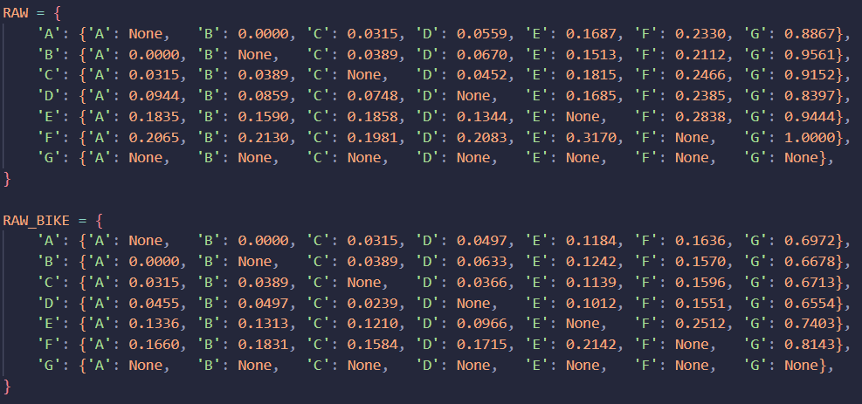
Figure 3:1 State Space
A state representation defines the variables used to determine whether two search results are equivalent for the purpose of cost comparison and pruning. In this implementation, a state is represented as:
key = (nxt, new_visited)
The “key” tuple captures two components: the current node (nxt) and the set of nodes that are already visited (new_visited). Representing the state by current node only would be insufficient in our implementation since the goal of the route problem is not merely reaching the destination but also visited all required nodes. For example, two paths on node C are not equivalent if one has visited {A, B, D} and the other visited {D, E, F}. Thus including “new_visited” as part of the state is essential to correctly distinguish the situation.
“new_visited” is implemented as a frozenset() rather than a list or standard set. This is necessary for two reasons: it can be used as a dictionary key; and it is also unordered, so two visited sets containing the same nodes in a different sequence (e.g. {A, B, C} vs {C, A, B}) are correctly treated as identical states rather than distinct ones. This is implemented because during heuristic calculation, it just needs to know which nodes are left, no matter the order. Using frozenset can keep the heuristic consistent, where MST calculation would always product the same result for the same group of unvisited nodes. Finally, this state representation ties directly into the goal state: when “new_visited” contains all the required nodes and “nxt” is on the goal node.
best_g = {(start, start_visited): 0.0}
best_g = {(‘C’, ‘A’, ‘B’, ‘C’): 15.0}
“best_g” contains an extra component than “key” – the lowest known cost to reach each state (node, visited) discovered so far. “best_g” indicates the cheapest known route for each route. For example, it costs 15 to reach node C while visiting node A, B, C. If a cheaper path of the same state is later discovered. “best_g” is updated to reflect the new lowest cost of that state.
This serves as a pruning mechanism where every newly generated path whose cost is higher than existing “best_g” value for the same state is ignored immediately.

Actions & Transition Model
Rather than a dedicated expandChildren() function, the actions and transition model in this implementation are handled by a nested loop structure: an outer while loop that expands the frontier, and an inner for loop that generates and validates the children nodes from the current node.
While frontier:
f, g, _, current, path, visited = heapq.heappop(frontier)
This loop continues if frontier is not empty. On each iteration, it:
- Pops the cheapest state inside frontier via heapq.heappop, populating the value of that state into “f, g, current, path, visited”
- It checks with best_g if a cheaper route to the same state has already been recorded. If so, then skip this iteration. This ensures that only the best version of each state is expanded
- As shown on figure 3:2: The state is then log into steps_log as a transition model and for visualization purposes.
- The goal test is then run and validated.
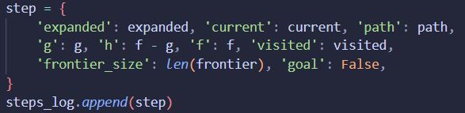
Figure 3:2: State Record Logging

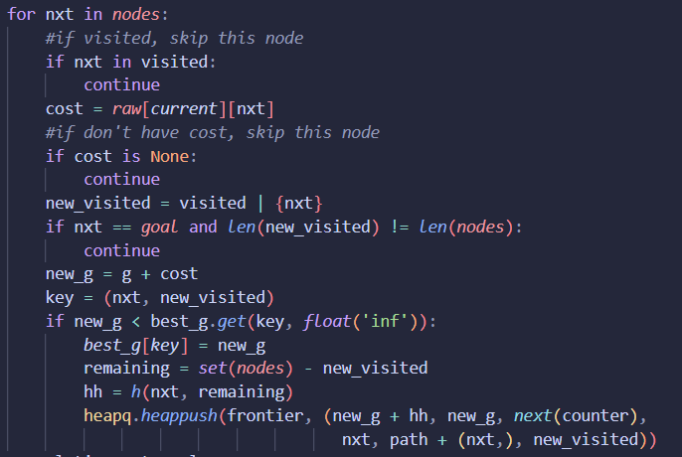
Figure 3:3 Inner For Loop
The for loop generates children edges from current node to every other node in the dataset, and applies validation to decide which of them are recorded:
- “nxt” represents a candidate child node, it checks if “nxt” is already visited. If so, skip this iteration. It also contains a path check to ensure such edge exist.
- A goal state check to ensure the algorithm doesn’t end before fulfilling all requirements
- The new cumulative cost “new_g” is compared against best_g for cheapest state check
- If accepted, the new state is pushed onto the frontier for future expansion, and the loop proceeds to the next candidate node

Heuristic Function
In A* seach, h(n) represents the estimated remaining cost from the current node to the goal node, guiding the search towards the promising directions rather than expanding uniformly like Uniform Cost Search (UCS). Our first approach in Assignment 1 is to use the raw normalized path cost to the goal node directly as h(n). This was ultimately rejected as it was a poor and potentially inadmissible heuristic for our specific problem formulation.
Thus, we chose MST as our heuristic function because the underlying requirements is an ASTP scenario, and after investigation for heuristic used in TSP-style planning, MST is a well-established choice for the case.
Critically, MST doesn’t compute the cheapest cost from current node to goal node, it instead attempts to compute the cheapest possible cost to connect all the remaining unvisited node together, entirely disregarding order and direction.
This distinction makes it an admissible heuristic as a heuristic is essentially admissible if it never overestimates the true remaining cost to the goal. Since MST defines the absolute cheapest cost to connect a set of nodes without redundant edge or cycles, the true remaining path cost can never be cheaper than MST cost. This guarantees h(n) <= true remaining cost in all cases.
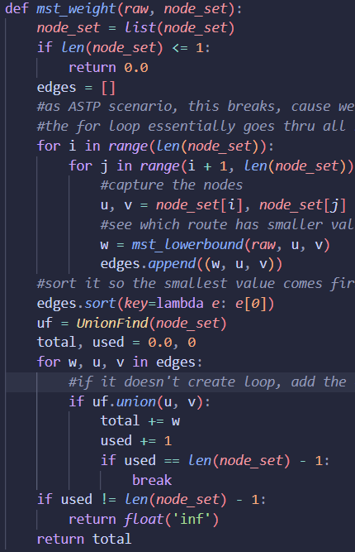
Figure 3:4 MST function
The workflow of mst_weight is:
- Ensure at least 2 nodes is presents for computation
- Generate all possible edges for the node set, and sort them ascendingly
- Groups edges together using UnionFind to detect and reject any edge that would form a cycle. This is essential because a cycle would mean paying for a redundant connection, which is never cheaper and would break MST
- A last termination check to ensure the spanning tree set always has exactly n-1 edges than the n nodes. If there’sfewer edges than that, it concludes that not all edges are connected.

However, the one complication is that MST assumes the route graph is undirected (TSP), meaning an edge’s cost is the same in both directions, whereas our actual route is asymmetric (ASTP). raw[A][B] and raw[B][A] is not necessarily equal. Using either direction would either overestimate the cost or misrepresents the graph.
To resolve this, mst_lowerbound converts the asymmetric graph into a symmetric graph for heuristic purposes only, by always taking the cheaper cost of the two directions. This is a deliberate underestimate: by assuming the cheaper direction is always available even thought the real route may be forced to take the more expensive ones, h(n) remains guaranteed to always underestimates, preserving admissibility. This transformation is ultimately what allows a TSP-only technique be used on a ASTP problem.
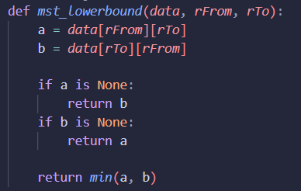
Figure 3:5 mst_lowerbound function
However, as the problem analysis mentioned, this project is an ATSP scenario, and MST only works on TSP as it is non-directional. To resolve that, we implement a lower-bound function where it always returns the cheaper direction. By further underestimating the total cost and ignores directional constraint, the project is converted into a TSP scenario where we could implement MST as the heuristic function.

Cost Function
The cost function of A* search algorithm contains:
f(n) = g(n) + h(n)
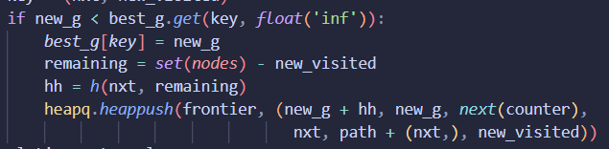
Figure 3:6 Cost Function
- f(n) = estimated total cost of the cheapest solution through node n
- g(n) = actual path cost from the start node to current node
- h(n) = cheapest cost to connect all the remaining nodes together

As mentioned above, h(n) is no longer the cheapest remaining total cost from node n to goal node, but rather the MST value for all remaining nodes.

Evaluation Function
The evaluation function is simply f(n), and it determines the order of expansion in this implementation. “frontier” is a min-heap(heapq), so the state with the lowest f(n) is always popped and expanded first. Because both g(n) and h(n) are admissible, f(n) guarantees the first complete solution found is the optimal solution.

Code Implementation Considerations
A few practical implementation choices support the effectiveness and efficiency of the algorithm:
- heapq as the dictionary of frontier, avoids a full linear scan of the frontier every iteration and could always insert and extraction the minimum state
- itertools.count() acts as a failsafe whenever if two states shares the same f(n) value, because Python would otherwise attempt to compare an unordered nodes or tuples
- frozenset() for visited sets to ensure each state inside best_g is order and directional independent.

Modification for Different Configurations
Our algorithm is already written and defined to use parameters rather than hardcoding dataset. This means switching to the motorbike dataset or any future dataset that follows the same structure requires no change to the search logic itself, only passing a different parameters into a_star_search().
Similarly, changing the required start/end nodes only requires updating the START / GOAL variable with no changes to heuristic, transition model, or pruning logic, since all three are defined generically over whatever node set and cost data is supplied.

Result Visualization
To make the behavior of the A* search algorithm easier to understand and verify, a visual simulation was built showing the search process live, side-by-side for both datasets (car routes on the left in red, motorbike routes on the right in blue). Rather than only presenting the final answer, this visualization lets us watch how the algorithm finds the answer: which nodes it considers, which paths it tries, and how it gradually narrows in on the cheapest complete route.
Each panel shows the seven locations (A–G) as circles on a grid, connected by arrows representing the route currently being explored. Below each panel, a running log displays the current path taken so far, along with three numbers explained earlier in this report: g (actual cost travelled so far), h (the algorithm's estimate of the cheapest way to still connect the remaining stops), and f (the combined total the algorithm uses to judge how promising a route is). A yellow-highlighted node marks where the algorithm currently "stands" in its exploration.

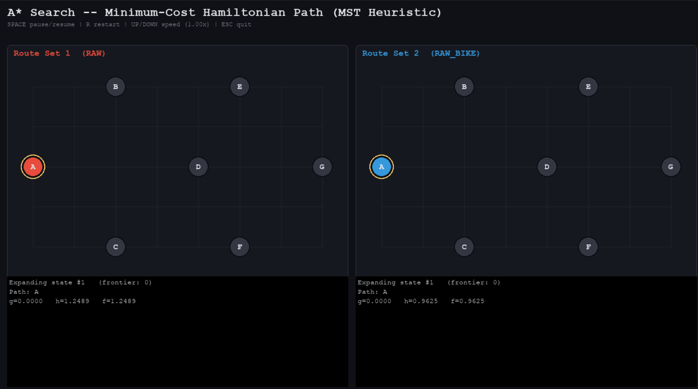
Figure 4:1 Initial Frame
The search begins at node A on both maps. No path has been taken yet (g = 0.0000), so the only cost shown is the heuristic estimate h — the algorithm's initial "guess" of the cheapest way to eventually connect all remaining nodes. Notice the car and motorbike maps already show different h values (1.2489 vs 0.9625) despite being the same graph — this is because the two datasets have different underlying travel costs, so the cheapest-connection estimate differs between them from the very first step.

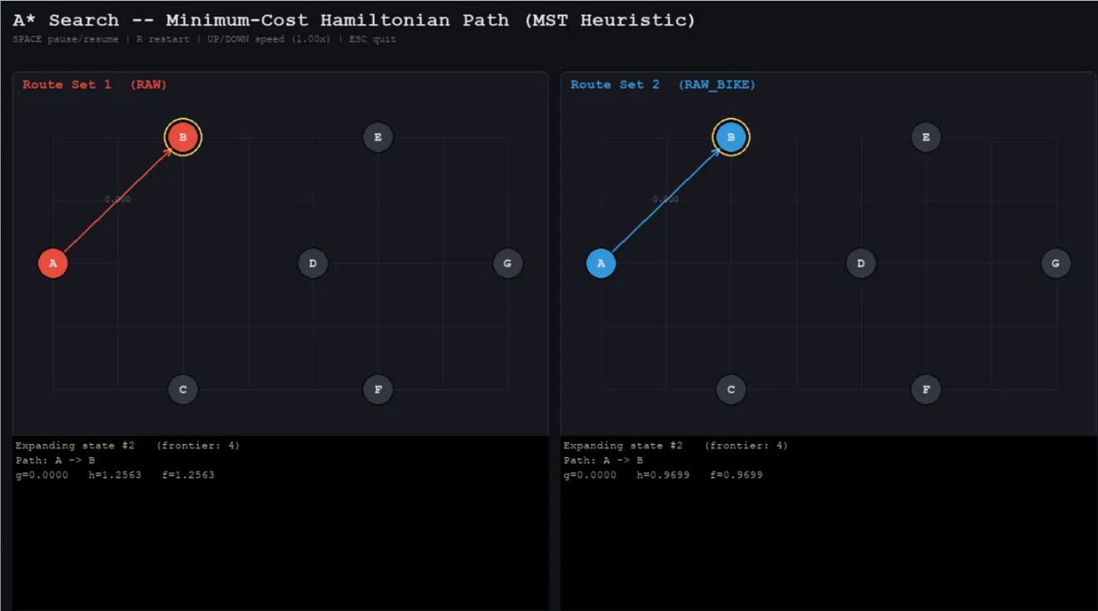
Figure 4:2 First Step
First expansion (A → B). The algorithm has taken its first step, moving from A to B, shown as the highlighted arrow on both maps. The path so far (A -> B) and its associated costs are logged below. At this early stage, both datasets happen to explore the same first move because they share the exact same g costing for the edge (A -> B), though their cost estimates continue to diverge based on their respective datasets.

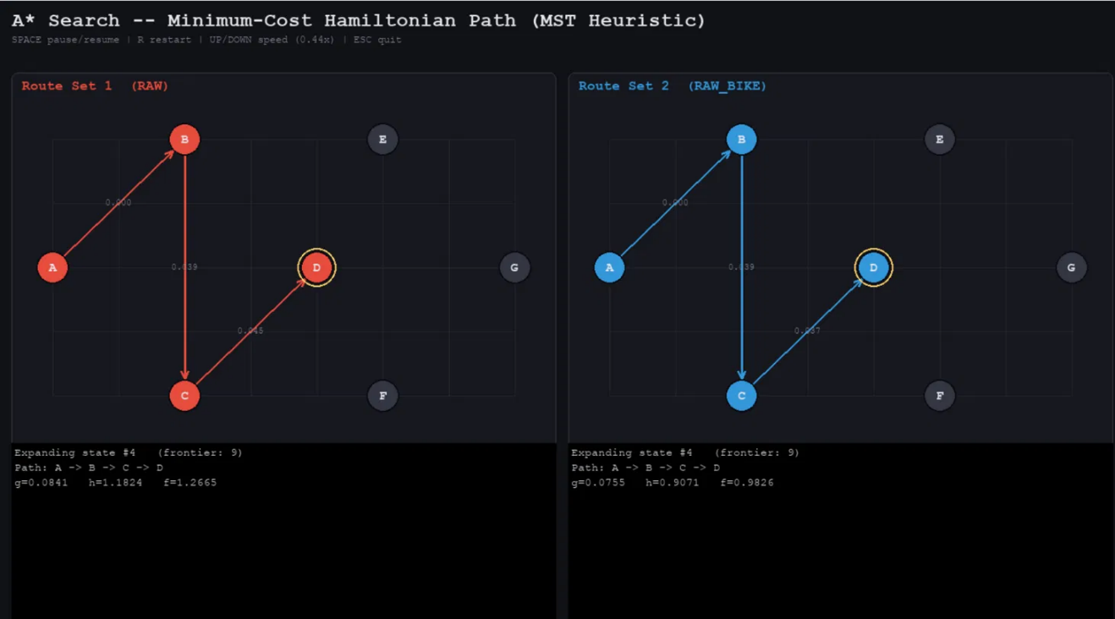
Figure 4:3 4th Step
Deeper into the search (A → B → C → D). A few steps later, the algorithm has extended its path further, now including C and D, with real travel costs (0.039, 0.045) accumulating into g. Both panels are still following the same path shape at this point, but the estimated remaining cost (h) is already noticeably lower for the motorbike route than the car route, hinting that the motorbike dataset may ultimately produce a cheaper overall solution.

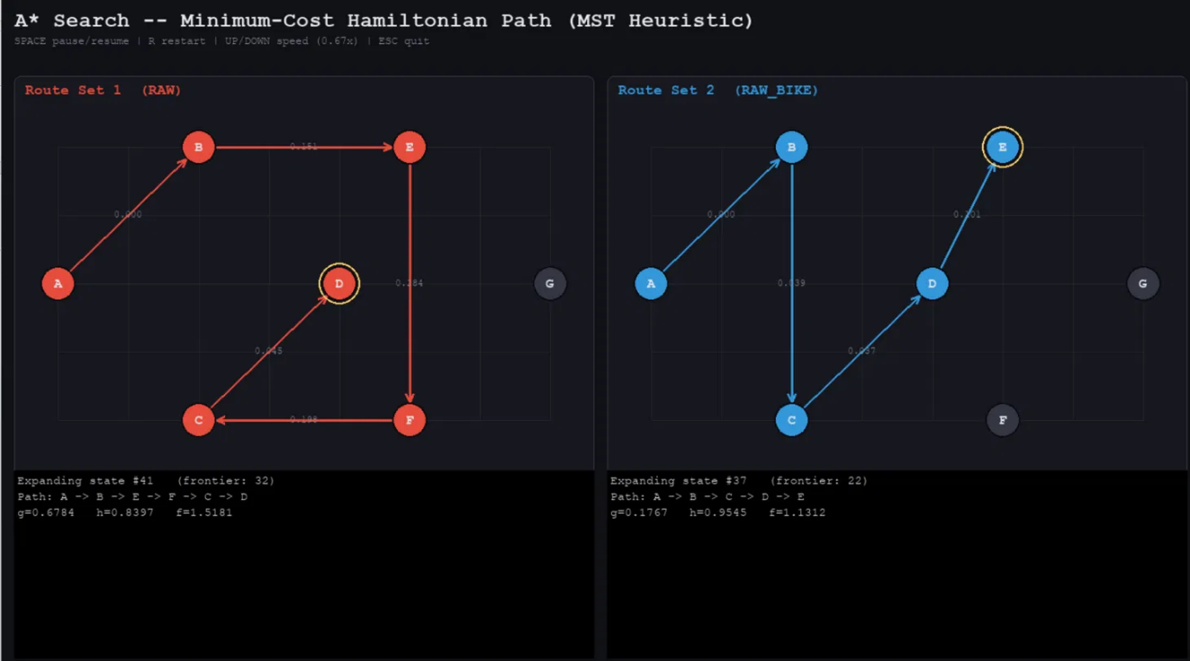
Figure 4:4 Last Step for Car Route before reaching goal state
Paths diverge (state #41 vs #37). By this point in the search, the two datasets have started exploring genuinely different paths — the car route follows A → B → E → F → C → D, while the motorbike route follows a different order, A → B → C → D → E. This reflects the two datasets having different cost structures: what's cheap by car isn't necessarily cheap by motorbike, so the algorithm's search naturally diverges as it hunts for each dataset's respective optimum. The number of states expanded so far (41 vs 37) also gives a sense of how much exploration each search has needed to reach this point.
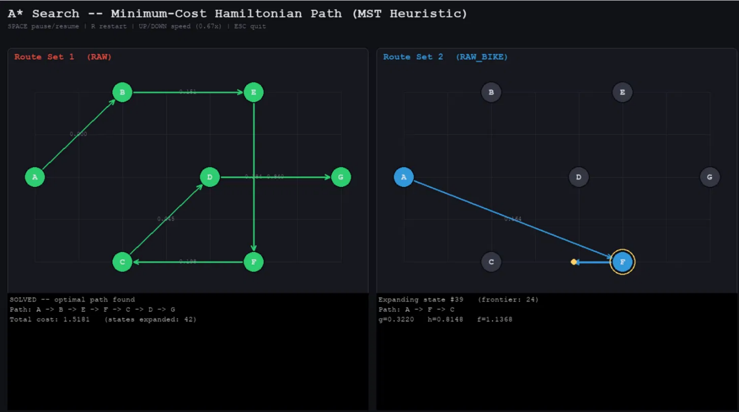
Figure 4:5 Car Route Optimal Route Found
Car route reaches a solution. The left panel now displays "SOLVED — optimal path found", with the complete route A → B → E → F → C → D → G and a final total cost of 1.5181, after exploring 42 states. This confirms the algorithm has found the cheapest possible way to visit every location by car and end at G. The right panel (motorbike) is still actively searching at this point, shown by its ongoing exploration (A -> F -> C) and ticking state counter.

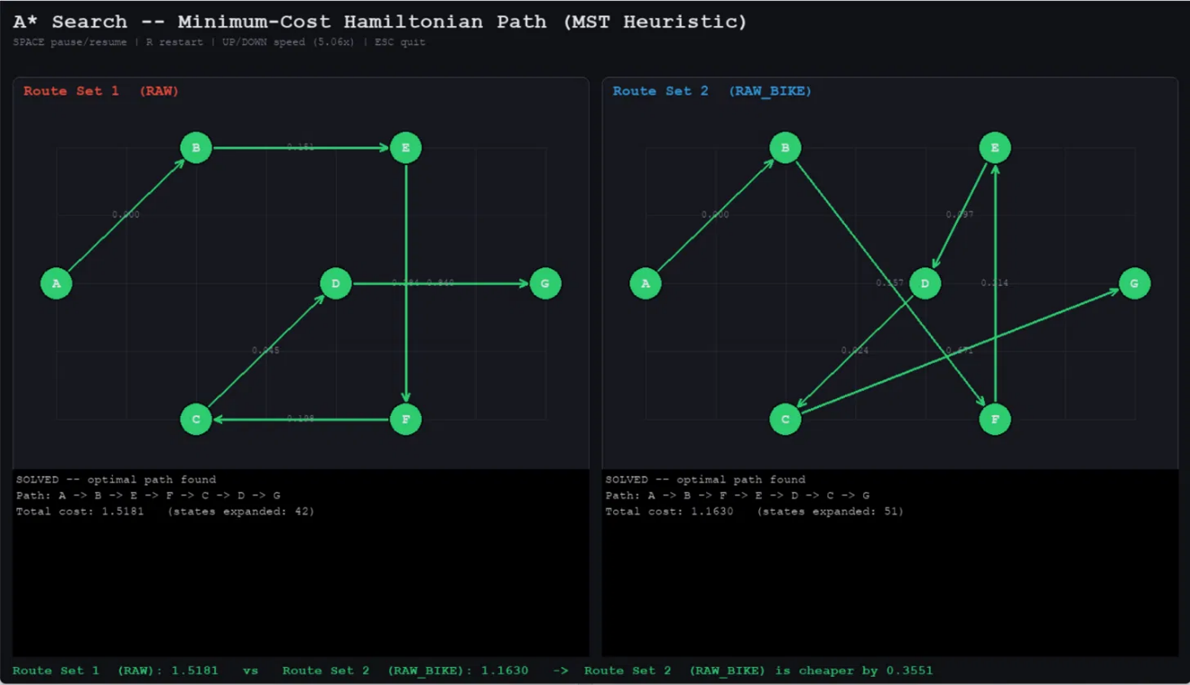
Figure 4:6 Both Route Optimal Route Found
Both routes solved and compared. Finally, both panels display "SOLVED," each with its own optimal path: the car route at a total cost of 1.5181 (42 states expanded), and the motorbike route at 1.1630 (51 states expanded), following the different path A → B → F → E → D → C → G. A final comparison line at the bottom summarizes the result in plain terms: the motorbike route is cheaper by 0.3551. This side-by-side outcome directly demonstrates the practical value of running A* separately over both datasets — the same set of locations produces two different optimal routes and two different total costs depending on mode of transport, and the visualization makes that difference immediately visible rather than requiring the underlying numbers to be manually compared.

Evaluation and Discussions
  - Advantage of Current Implementation
    - Guaranteed optimal route & Admissible Heuristic
Compared to earlier rejected approach, the MST heuristic performs much better. Even though both reached the same route with the same costing, MST only requires 42 expansions meanwhile earlier approach requires 100+ expansions. However, earlier approach allows cycles route, meanwhile MST does not. And because of MST-based heuristic, the algorithm is guaranteed to return the absolute cheapest path.
    - Scalable and Flexible Implementation
Due to not hardcoding the datasets and passed them as parameters, the same implementation runs unmodified on any similar structure dataset. Moreover, this approach enables easier modification and improvements to the algorithms with minimal structure change.
    - Efficient Pruning
The “best_g” avoids re-expanding dominated states, as you could see if you ran the scripts, it would skip frontiers without showing the expansion, because it got ignored as it isn’t the optimal route for that state. The min-heap frontier ensures the cheapest candidate is always explored next, keeping the search reasonably efficient.

  - Disadvantage of Current Implementation
    - Exponential State Space
Representing the state as (node, visited) means the number of edges grows on n * 2^n. It is still manageable for 7 nodes, but it will ultimately be tremendously computational heavy for larger node sets.
    - Loss of directional Information in Heuristic
mst_lowerbound always take the cheaper edge of the two directions. While this preserve admissibility, it can also be less admissible if the dataset is highly asymmetric. Since the heuristic assumes an optimal direction where actual transversal cannot be made, it could potentially lead to more node expansion than a better ASTP-specific heuristic would need.

  - Possible Improvements
- Caching MST calculations across expansions that shares the same or similar unvisited node sets. Currently the algorithm recomputes from scratch every time, by applying caching, it would reduce redundant computation without affecting correctness.
- Using better heuristic specialized to ASTP specifically. Currently the algorithm forces our case scenario into TSP problem, it may not be optimal and functions as great as other heuristic. Thus, exploring a ASTP specialized heuristic is essential for future improvements.

  - Discussions about motorbike route requires more state expansion than car
Data from our script shows that A* search algorithm reached goal state for the car route data after 42 expansions, meanwhile it took 51 expansions for the motorbike route data. After investigation, we’ve hypothesized that it is due to motorbike having a smaller data variance than car on the entry cost of the goal node (G).
Car | Motorbike
D→G: 0.8397 | D→G: 0.6554
A→G: 0.8867 | B→G: 0.6678
C→G: 0.9152 | C→G: 0.6713
E→G: 0.9444 | A→G: 0.6972
B→G: 0.9561 | E→G: 0.7403
F→G: 1.0000 | F→G: 0.8143

Gap between best and next-best option:
- Car: 0.8867 − 0.8397 = 0.0470 (≈5.60% relative to the best value)
- Motorbike: 0.6678 − 0.6554 = 0.0124 (≈1.89% relative to the best value)
This difference in variance would cause the algorithm to expand further on other “nearly as good” branches before reaching the final optimal route. So we are suspecting that this is the main reason behind motorbike needing more state expansions than car to reach optimal route.

